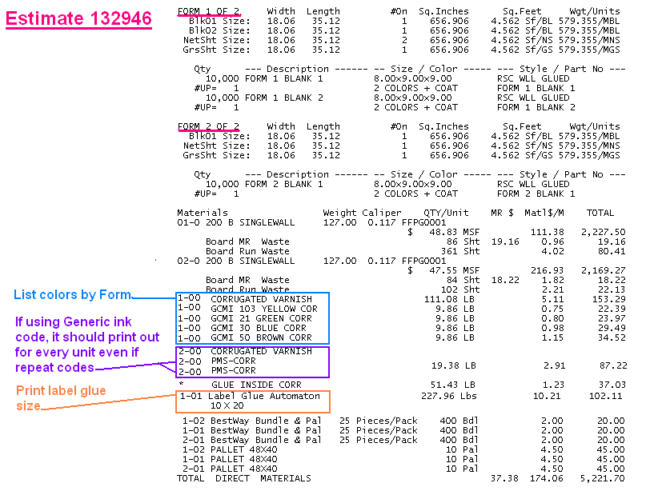
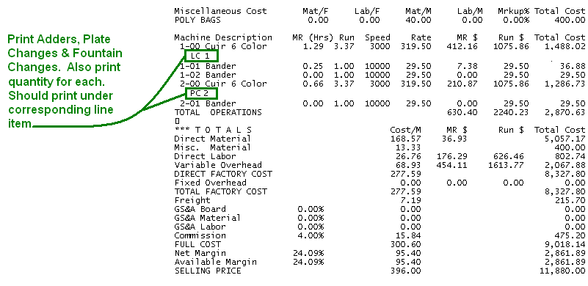
Misc Page – When adding multiple quantities under Matl/M & Labor/M , after hitting SAVE, the last quantity always defaults to 99,999,999. We need the system to not default to that quantity but add another line item for that quantity. We want to be able to view this screen and see the actual last quantity that was quoted.

